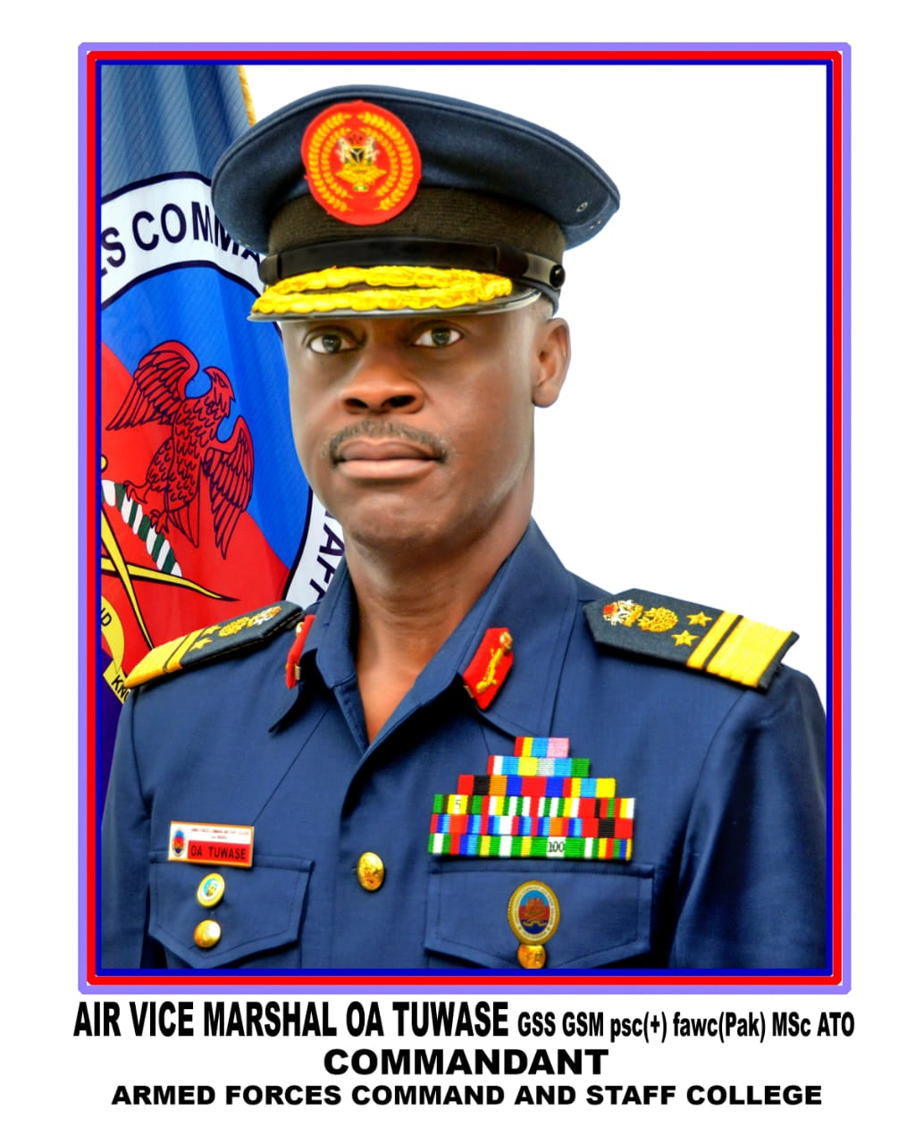

Air Vice Marshal Oluroti Anthony Tuwase was born on 1 Dec 1965 at Onitsha. He hails from Kabba/Bunnu Local Governement Area of Kogi State. He was admitted into the Nigerian Defence Academy in 1985 as a member of 37 Regular Combatant course. He was Commissioned in September 1990 as a Pilot Officer in the Nigerian Air Force (NAF). He attended several training courses amongst which include Orientation Engineering Course at the then Technical Training Group now Air Force Institute of Technology. He was type-rated Alpha Jet Engine in 1992 at Air Weapon School at New-Bussa. The Senior officer also attended the Junior and Senior Staff Course at this prestigious Armed Forces Command and Staff College Jaji. The Senior officer returned to the College as a Directing Staff. AVM OA Tuwase has held several Command, Staff and Instructional appointments, prominent amongst which are; Officer Commanding Armament Squadron, Nigerian Air Force Detachment ECOMOG in Liberia and Sierra Leone, Command Armament Officer HQ Logistics Command Ikeja and Deputy Director Ground Safety HQ NAF. He was also the Commander of the 405 Central Armament Depot and Director of Armament HQ NAF. Air Vice Marshal OA Tuwase was the Director of Procurement Logistic Branch HQ NAF before being appointed as the Twenty Fifth Commandant of the Armed Forces Command and Staff College on 7 Jan 20. Air Vice Marshal OA Tuwase is highly recognized and honoured for his exemplary leadership, professionalism and great inputs to ensure conducive environment for improved learning in the Department of Land Warfare.

